Experiment 14: write a Python program to implement the Alpha-Beta Pruning Algorithm.
Aim
To write a Python program to implement the Alpha-Beta Pruning Algorithm.

Algorithm
Define the game tree values.
Create the Alpha-Beta function.
Initialize alpha and beta values.
Traverse the game tree recursively.
Update alpha and beta values.
Prune unnecessary branches when alpha becomes greater than or equal to beta.
Display the optimal value.

Program
def alphabeta(depth, node, isMax, values, alpha, beta):

if depth == 3:
return values[node]

if isMax:
best = -1000

for i in range(2):
best = max(best,
alphabeta(depth+1, node*2+i,
False, values, alpha, beta))

alpha = max(alpha, best)

if beta <= alpha:
break

return best

else:
best = 1000

for i in range(2):
best = min(best,
alphabeta(depth+1, node*2+i,
True, values, alpha, beta))

beta = min(beta, best)

if beta <= alpha:
break

return best

values = [3,5,6,9,1,2,0,-1]

print("Optimal Value:",
alphabeta(0,0,True,values,-1000,1000))

Output
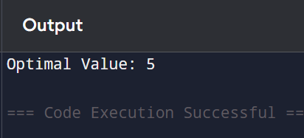
Result
Thus, the Python program to implement the Alpha-Beta Pruning Algorithm was executed successfully, and the optimal value was obtained.

